Microsoft Windows Vista PPTP Client Setup How To

To get started, you will need the following information:
- VPN server name: This will be either an IP address or a host name.
- VPN username: If you are a member of a Windows domain, this is most likely the same username you use to login to your computer.
- VPN password: If you are a member of a Windows domain, this is most likely the same username you use to login to your computer.
- (optional) DNS domain name suffix

Open the Control Panel (click on the Start button and then select Control Panel). In the text box on the top right, type in network. You should then see the Network and Sharing Center icon in the list below. Double click on it.

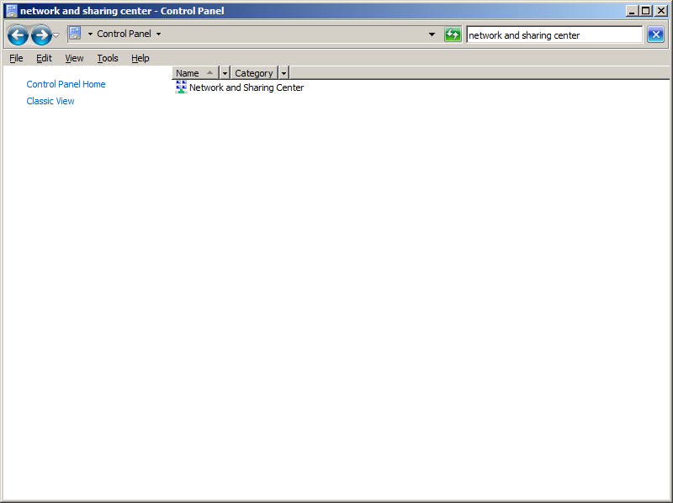

Once in the Network and Sharing Center, click on Set up a connection or network.

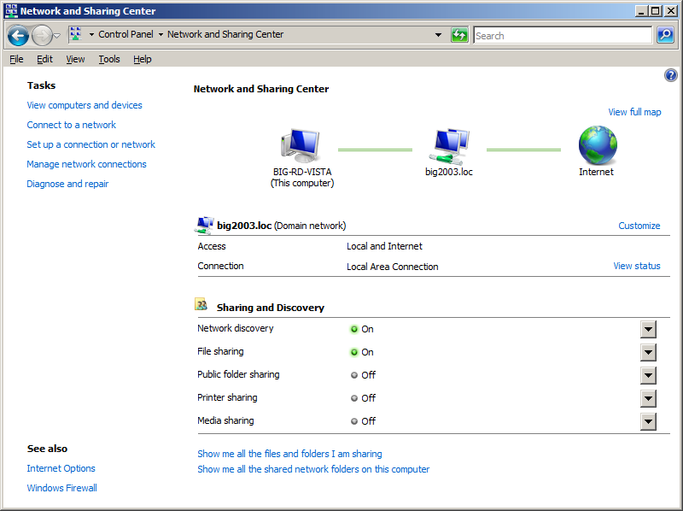

Select Connect to a workplace and click the Next button.

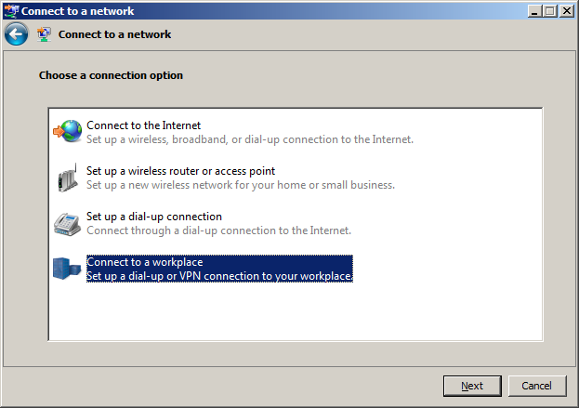

Select No, create a new connection and click the Next button.

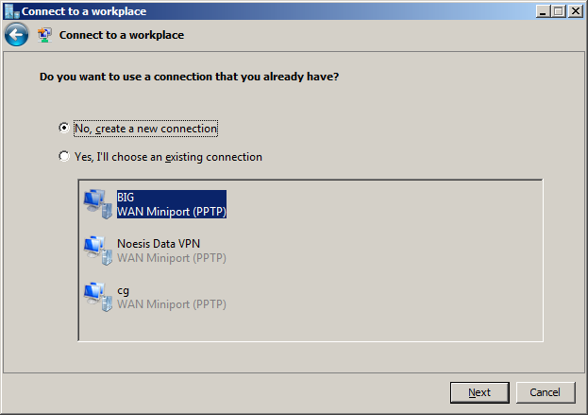

Click on Use my Internet connection (VPN).

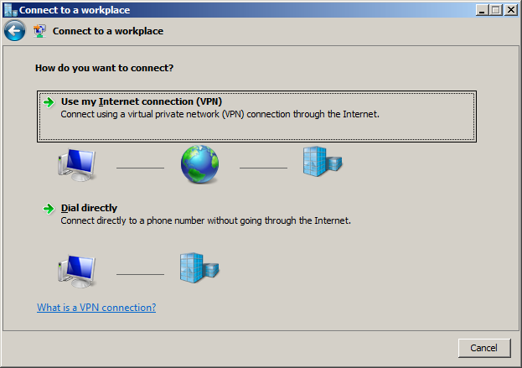

If you see this screen, just select I’ll set up an Internet connection later.

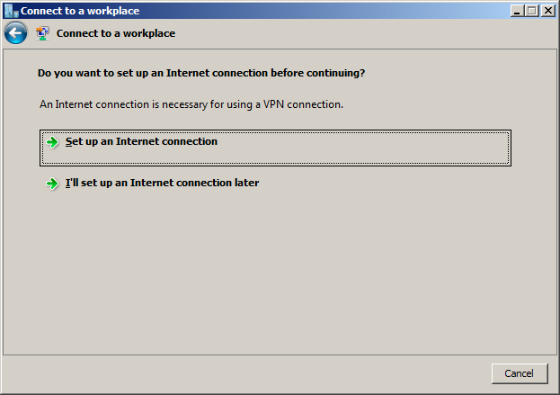

In the Internet address text box, enter the hostname or IP address of your VPN server. In the Destination name text box, enter the name of your company. Make sure the Don’t connect now; just set it up so I can connect later box is checked and click the Next button.

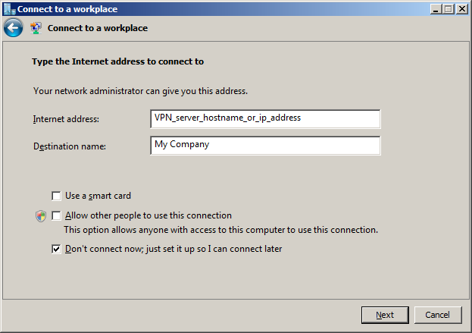

Enter your username and password and then click the Create button.

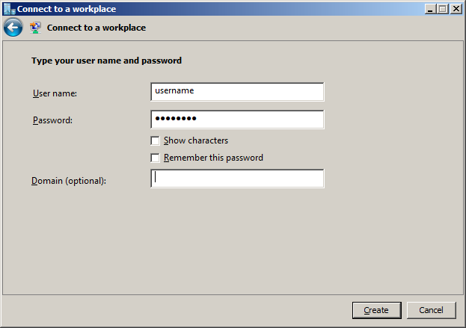

Click the Close button.

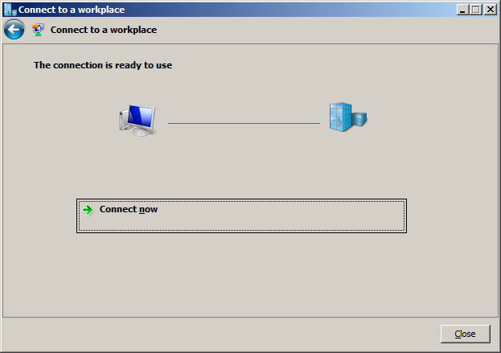

You should now be back to the Network and Sharing Center. Click on the Manage network connections link.

Right click on your newly created VPN connection and click Properties.

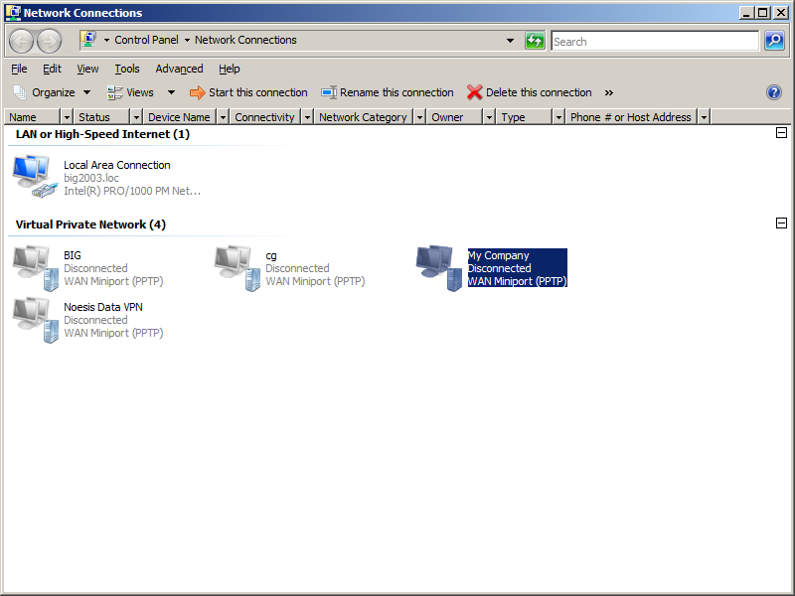

Click on the Networking tab.

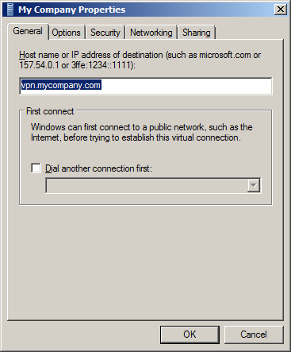

Select Internet Protocol Ver 4 (TCP/IPv4) and click the Properties button.

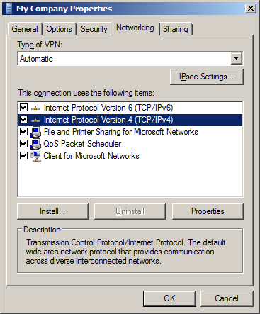

Click the Advanced button.

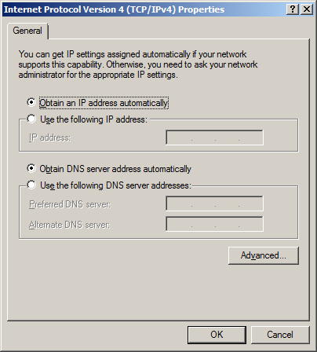

Make sure the Use default gateway on remote network box in blank and click the OK button. Continue clicking the OK buttons until you are back to the Network Connection screen.

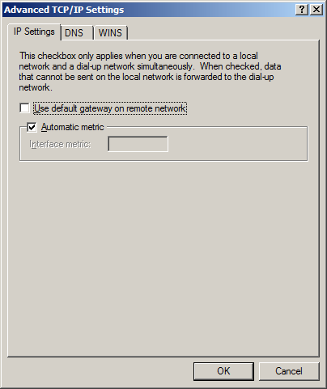

If you have been instructed to, fill in your DNS suffix for this connection: and click the OK button.

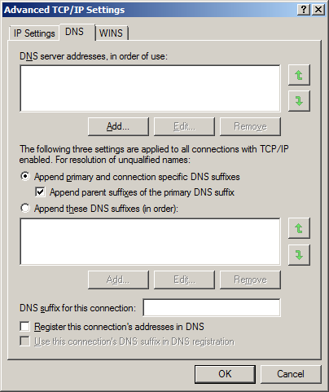

Right click on your VPN connection icon and click Create shortcut.

Click Yes to place a shortcut on your desktop.

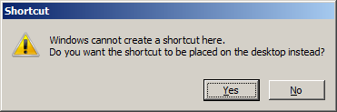

Find your way to the new shortcut on your desktop and double click to open it. Enter your username and password and click Connect.

